SWISS ARMY KNIFE INDICATOR
John F. Ehlers

The indicator I describe in this article does all the common functions of the usual indicators, such as smoothing and momentum generation. It also does some unusual things, such as band stop and band reject filtering. Once you program this indicator into your trading platform you can do virtually any technical analysis technique with it. This unique general indicator results from general Digital Signal Processing (DSP) concepts for discrete signal networks that appear in various forms in technical analysis.

The description of this indicator involves Z Transforms. Z Transforms are a convenient way of solving difficult difference equations in much the same way as LaPlace Transforms are used to solve differential equations in calculus. Difference equations arise from the use of sampled data, such as we have in technical analysis. That is, daily bars sample price data once a day. Intraday bars sample price data every minute, hour, or whatever. The concept is the same regardless of the sampling rate. In Z Transforms, Z⁻¹ stands for one sample period of delay. For simplicity, I will always refer to daily bars as the sample rate.

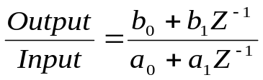The Transfer Function of a discrete linear system is the ratio of the output of the system divided by the input. Since both the output and input can be described in terms of polynomials in the Z domain, we can write the Transfer Function of a very simple indicator where as:

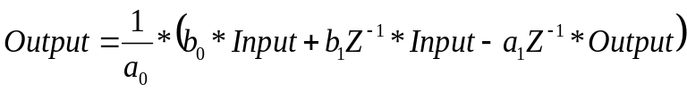In this case, both the input and output involve only a constant term and a term having one unit of delay. By cross multiplying and factoring, we can describe the output in terms of the input as:
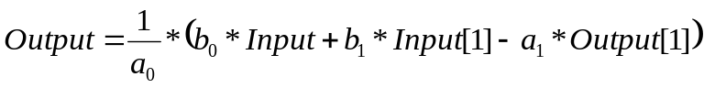This equation is easily converted to indicator programming languages. For example, in EasyLanguage, “N” units of delay is denoted by [N] after the variable. Thus the Transfer Function programs to:

Suppose that a₀=1, b₀=α, b₁=0, and a₁=-(1- α). In this case, the programmed equation is:

In other words, the generalized simple expression programs to become the familiar exponential moving average. Note that the coefficients for the input term and the output term sum to one. This means that the DC (Direct Current), or zero frequency, value of the filter is unity so that if the input is constant for a long time, the output is (nearly) equal to the input.

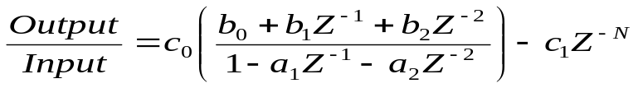With this introduction, you are ready for the Swiss Army Knife Indicator. The transfer response is a rational expression of two second order polynomials as:

Converting this to a programmable equation, we obtain:
All we have to do now is to establish a table for the various coefficients to implement the Swiss Army Knife Indicator. The equation need be only programmed once, and each of the coefficient sets can be “remarked out” except for the coefficient set desired in any instance.

Exponential Moving Average (EMA)

You have already been exposed to the EMA. The complete coefficient set is

 | c₀ | c₁ | N | b₀ | b₁ | b₂ | a₁ | a₂
EMA | 1 | 0 | 0 | α | 0 | 0 | (1-α) | 0

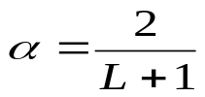But what does α mean? Alpha is commonly related to the equivalent smoothing of a Simple Moving Average (SMA) of length L as:
If you tend to think of the market data in terms of its frequency content as I do, the relationship between alpha and the cycle period where the corner of the attenuation starts is:
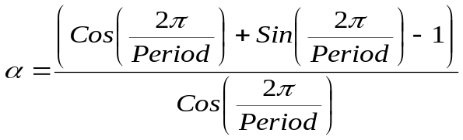In EasyLanguage, Sines and Cosines are computed in degrees rather than in radians, and therefore 360 should be substituted for 2π. As a check on your math, if we want to attenuate all cycle components shorter than 20 bars, we compute α = .2735. This is roughly equivalent to a six bar SMA.

Simple Moving Average (SMA)

A simple moving average sums “N” samples of data and divides the sum by N. A more efficient method of computing a SMA is to drop off the oldest term and add the newest data value divided by N. To implement this method of computing an SMA of length N, the coefficients of the Swiss Army Knife Indicator are:

 | c₀ | c₁ | N | b₀ | b₁ | B₂ | a₁ | a₂
SMA | 1 | 1/N | N | 1/Ν | 0 | 0 | 1 | 0

Be careful of using this implementation of the SMA is initialization. For example, if you start with a zero value of the SMA and you are averaging a Stock whose price is approximately 30, it will take quite some time for the SMA to recover from the incorrect initial value. Initialization error recovery time can be reduced with a line of code something like:
If CurrentBar < N then SMA = Price;

Two Pole Gaussian Filter

A Gaussian Filter offers a very low lag compared to other smoothing filters of like order. (The order is the largest exponent in the transfer equation). It can be implemented by taking an EMA of an EMA, but that method leaves the computation of the correct alpha to be a little nebulous. The double EMA is the equivalent of squaring the Transfer Response of an EMA. Therefore, the coefficients of the Swiss Army Knife Indicator for the two pole Gaussian Filter are:

 | c₀ | c₁ | N | b₀ | b₁ | B₂ | a₁ | a₂
Gauss | α² | 0 | 0 | 1 | 0 | 0 | 2(1-α) | -(1-α)²

The correct value of alpha is related to the cutoff period that you wish to attenuate. It can be computed as:

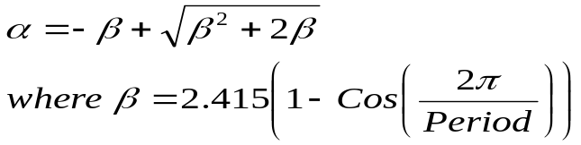

Please note that alpha has a different meaning than it did in the EMA equation. The same is true for beta in subsequent calculations.

Figure 1 shows a theoretical “chirped” sinewave whose period is slowly increasing from a 10 bar cycle at the left of the screen to a 40 bar cycle at the right of the screen. The Period for the Gaussian Filter is set at 20, which is near the center of the screen. Figure 1 shows that the Gaussian Filter is a Low Pass filter, allowing the lower frequencies to pass and attenuating the higher frequencies.

Figure 1. Gaussian Filter Attenuates Shorter Cycles

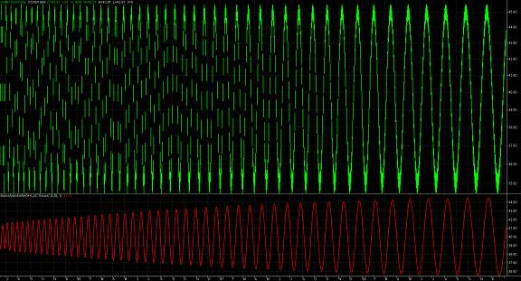

Two Pole Butterworth Filter

The response of a two pole Butterworth Filter can be approximated by introducing a second order polynomial with binomial coefficients in the numerator of the Transfer Response of the Gaussian Filter. The alpha is computed the same as for the Gaussian Filter. Doing this, the Swiss Army Knife Indicator coefficients are:

 | c₀ | c₁ | N | b₀ | b₁ | b₂ | a₁ | a₂
Butter | α²/4 | 0 | 0 | 1 | 2 | 1 | 2(1-α) | -(1-α)²

While trivial, but shown for completeness, a low lag three tap smoothing filter is obtained by eliminating the higher order terms in the denominator of the Transfer Response. This smoother is implemented using the coefficients:

 | c₀ | c₁ | N | b₀ | b₁ | b₂ | a₁ | a₂
Smooth | 1/4 | 0 | 0 | 1 | 2 | 1 | 0 | 0

The smoothing realized from this filter is extremely modest, rejecting only the 2 bar cycle component.

High Pass Filter

A High Pass Filter is the more general version of a momentum function. Its purpose is to eliminate the constant (DC) term and lower frequency (longer period) terms that do not contribute to the shorter term cycles in the data.

 | c₀ | c₁ | N | b₀ | b₁ | b₂ | a₁ | a₂
HP | 1-α/2 | 0 | 0 | 1 | -1 | 0 | (1-α) | 0

Alpha for the High Pass Filter is computed exactly the same as it is for the EMA. That is:
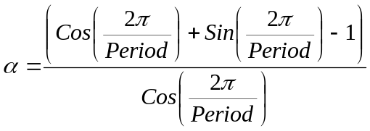
Two Pole High Pass Filter

Just as we got sharper filtering by squaring the Transfer Response of the EMA to get a Gaussian Low Pass Filter, we can square the Transfer Response of the High Pass filter to improve the filtering. In general, there is an approximate one bar lag penalty for obtaining the improved filtering. The Swiss Army Knife Indicator coefficients are:

 | c₀ | c₁ | N | b₀ | b₁ | b₂ | a₁ | a₂
2PHP | (1-α/2)² | 0 | 0 | 1 | -2 | 1 | 2(1-α) | -(1-α)²

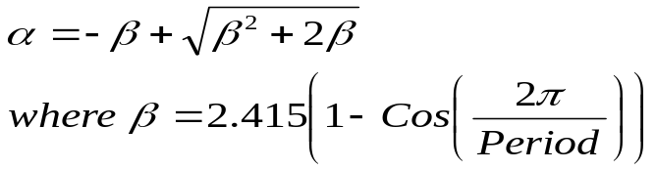Alpha is computed exactly the same as for the Gaussian response. That is:

Figure 2 shows the same theoretical “chirped” sinewave and the 2PHP response. The Period for the 2PHP Filter is set at 20, which is near the center of the screen. Figure 2 shows that the 2PHP Filter is a High Pass filter, allowing the higher frequencies to pass and attenuating the lower frequencies.

Figure 2. 2PHP Filter Attenuates Longer Cycles
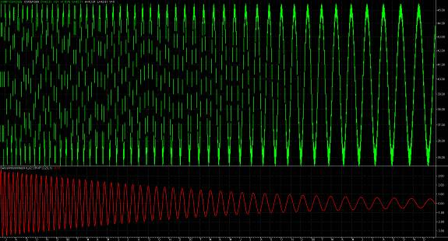

BandPass Filter

This is where the Swiss Army Knife Indicator really starts to get interesting! It can generate bandpass response to extract only the frequency component of interest. For example, if you want to examine the weekly cycle in the data, just set the period to 5. Monthly data can be extracted by setting the period to 20, 21, or 22. Since the passband of the filter is finite, the exact setting of the center period is not crucial.

Another way to use the BandPass Filter is to create a bank of them, separated by a fixed percentage, and display all of the filter outputs as an indicator set. Doing this, you can see at which filter the data peaks the strongest. For filters tuned to periods shorter than the dominant cycle in the data, the filter response will peak before the peak in the data. Filters tuned to periods longer than the dominant cycle in the data, the filter response will peak after the peak in the data. This way, you can estimate the current dominant cycle and, if the data are stationary, you can even predict the turning point.

The Swiss Army Knife Indicator coefficients for the BandPass Filter are:

 | c₀ | c₁ | N | b₀ | b₁ | b₂ | a₁ | a₂
BP | (1-α)/2 | 0 | 0 | 1 | 0 | -1 | β(1-α) | −α

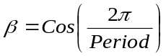In this case,
Don’t forget to substitute 360 for 2π in some languages. So, if you wanted to examine monthly data, the value of Beta would be 0.951.

The selectivity of the BandPass filter is established by the variable alpha. Alpha is a function of the center frequency of the filter as well as the width of the passband. Letting ±δ be the descriptor of the filter passband, where δ is a percentage of the center, we can compute alpha as:
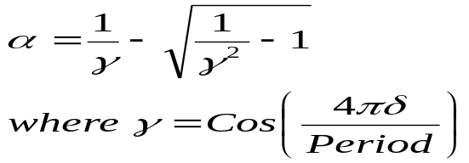It is easy to get carried away with trying to make the BandPass Filter passband either be too narrow or too wide. As a guideline, I suggest keeping the half bandwidth between 5 percent and 50 percent. That is 0.05 < δ < 0.5.

Figure 3 shows the same theoretical “chirped” sinewave and the Bandpass response of the Swiss Army Knife Indicator. The Period for the BandPass Filter is set at 20, which is near the center of the screen. The BandPass response speaks for itself.

Figure 3. BandPass Response Allows only a Range of Frequencies to Pass
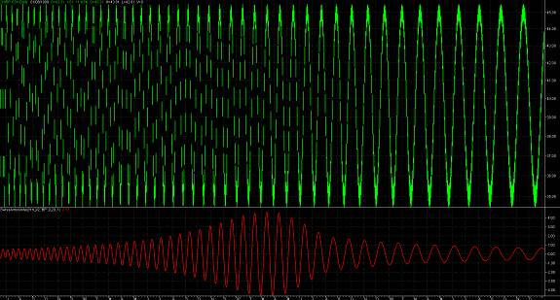

BandStop Filter

It might be interesting to also examine the data if the weekly or monthly components were removed, leaving all the other components in place. The alpha and beta variables are computed exactly as they were for the BandPass filter. The Swiss Army Knife coefficients are:

 | c₀ | c₁ | N | b₀ | b₁ | b₂ | a₁ | a₂
BS | (1+α)/2 | 0 | 0 | 1 | -2β | 1 | β(1+α) | −α

An interesting set of indicators would be to compute a bank of BandStop Filters, each having a percentage increase in the value of the center period, and plot them overlaid on your barchart. The smoothest curve would be the one with the dominant cycle removed. The shorter and longer filters can also give you insight into the market action.

Figure 4 again shows the same theoretical “chirped” sinewave, but with the BandStop response of the Swiss Army Knife Indicator. The Period for the BandStop Filter is set at 20, which is near the center of the screen. The BandStop response speaks for itself.

Figure 4. BandStop Response Blocks a Range of Frequencies
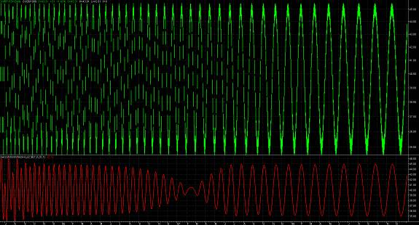

Sliding Digital Fourier Transform (DFT)

Fourier Transforms are useless for Technical Analysis because the data are simply not stationary for a sufficient duration to make a valid estimate of the spectrum. Vastly superior spectrum estimates can be made with the MESA algorithm or measurements of the dominant cycle can be made using the Hilbert Transform. I include the description of the DFT here simply to show that it can be done with the Swiss Army Knife Indicator. The coefficients are:

 | c₀ | c₁ | N | b₀ | b₁ | b₂ | a₁ | a₂
DFT | re^{jθ} | r^{N} re^{jθ} | N | 1 | 0 | 0 | 1 | 0

For stability, r is any number slightly less than unity – like 0.999. As with all Fourier Transforms, analysis is performed only at discrete periods. Those periods are “k” where k <= N, and the variable theta is computed as θ = 2πk/N.

The programming solution involves complex arithmetic. Since the DFT is useless for trading, I have not included it in the Swiss Army Knife EasyLanguage code. If you try to contact me for the code, you do so at the peril of being branded an idiot for trying to use a DFT in the first place.

SUMMARY

The Swiss Army Knife Indicator is a versatile approach that creates a wide variety of responses that range from smoothers to oscillators. Novel BandPass and BandStop filters can also be produced. All of this can be done with one line of code in most platforms. The various responses come from the coefficients that can be called – as functions if you prefer. In Figure 5 the EasyLanguage formulation shows the coefficients as variables that are initialized to the default values and are changed in block conditional statements. This makes indicator programming extremely simple. Table 1 summarizes the coefficients for the ten separate and distinct responses that can be generated from the single Swiss Army Knife Indicator.

Table 1. Swiss Army Knife Coefficients
 | c₀ | c₁ | N | b₀ | b₁ | b₂ | a₁ | a₂
default | 1 | 0 | 0 | 1 | 0 | 0 | 0 | 0
EMA | 1 | 0 | 0 | α | 0 | 0 | (1-α) | 0
SMA | 1 | 1/N | N | 1/Ν | 0 | 0 | 1 | 0
Gauss | α² | 0 | 0 | 1 | 0 | 0 | 2(1-α) | -(1-α)²
Butter | α²/4 | 0 | 0 | 1 | 2 | 1 | 2(1-α) | -(1-α)²
Smooth | 1/4 | 0 | 0 | 1 | 2 | 1 | 0 | 0
HP | 1-α/2 | 0 | 0 | 1 | -1 | 0 | (1-α) | 0
2PHP | (1-α/2)² | 0 | 0 | 1 | -2 | 1 | 2(1-α) | -(1-α)²
BP | (1-α)/2 | 0 | 0 | 1 | 0 | -1 | β(1-α) | −α
BS | (1+α)/2 | 0 | 0 | 1 | -2β | 1 | β(1+α) | −α
DFT | re^{jθ} | r^{N} re^{jθ} | N | 1 | 0 | 0 | 1 | 0

Figure 5. Swiss Army Knife EasyLanguage Code
{
SWISS ARMY KNIFE INDICATOR
by John Ehlers
}

Inputs:
Price((H+L)/2),
Type("BP"),
N(0),
Period(20),
delta1(.1);

Vars:
c0(1),
c1(0),
b0(1),
b1(0),
b2(0),
a1(0),
a2(0),
alpha(0),
beta1(0),
gamma1(0),
Filt(0);

If Type = "EMA" Then Begin
If CurrentBar <= N then Filt = Price;
alpha = (Cosine(360/Period) + Sine(360/Period) - 1) / Cosine(360/Period);
b0 = alpha;
a1 = 1 - alpha;
End;

If Type = "SMA" Then Begin
If CurrentBar <= N then Filt = Price;
c1 = 1 / N;
b0 = 1 / N;
a1 = 1;
End;

If Type = "Gauss" Then Begin
If CurrentBar <= N then Filt = Price;
beta1 = 2.415*(1 - Cosine(360 / Period));
alpha = -beta1 + SquareRoot(beta1*beta1 + 2*beta1);
c0 = alpha*alpha;
a1 = 2*(1 - alpha);
a2 = -(1 - alpha)*(1 - alpha);
End;

If Type = "Butter" Then Begin
If CurrentBar <= N then Filt = Price;
beta1 = 2.415*(1 - Cosine(360 / Period));
alpha = -beta1 + SquareRoot(beta1*beta1 + 2*beta1);
c0 = alpha*alpha / 4;
b1 = 2;
b2 = 1;
a1 = 2*(1 - alpha);
a2 = -(1 - alpha)*(1 - alpha);
End;

If Type = "Smooth" Then Begin
c0 = 1 / 4;
b1 = 2;
b2 = 1;
End;

If Type = "HP" Then Begin
If CurrentBar <= N then Filt = 0;
alpha = (Cosine(360/Period) + Sine(360/Period) - 1) / Cosine(360/Period);
c0 = 1 - alpha / 2;
b1 = -1;
a1 = 1 - alpha;
End;

If Type = "2PHP" Then Begin
If CurrentBar <= N then Filt = 0;
beta1 = 2.415*(1 - Cosine(360 / Period));
alpha = -beta1 + SquareRoot(beta1*beta1 + 2*beta1);
c0 = (1 - alpha / 2)*(1 - alpha / 2);
b1 = -2;
b2 = 1;
a1 = 2*(1 - alpha);
a2 = -(1 - alpha)*(1 - alpha);
End;

If Type = "BP" Then Begin
If CurrentBar <= N then Filt = Price;
beta1 = Cosine(360 / Period);
gamma1 = 1 / Cosine(720*delta1 / Period);
alpha = gamma1 - SquareRoot(gamma1*gamma1 - 1);
c0 = (1 - alpha) / 2;
b2 = -1;
a1 = beta1*(1 + alpha);
a2 = -alpha;
End;

If Type = "BS" Then Begin
If CurrentBar <= N then Filt = Price;
beta1 = Cosine(360 / Period);
gamma1 = 1 / Cosine(720*delta1 / Period);
alpha = gamma1 - SquareRoot(gamma1*gamma1 - 1);
c0 = (1 + alpha) / 2;
b1 = -2*beta1;
b2 = 1;
a1 = beta1*(1 + alpha);
a2 = -alpha;
End;

If CurrentBar > N Then Begin
Filt = c0*(b0*price + b1*Price[1] + b2*Price[2]) + a1*Filt[1] + a2*Filt[2] - c1*Price[N];
Plot1(Filt, "Swiss");
End;

Combinations of several Swiss Army Knife outputs can also make a wide variety of new and unique indicators. For example, a MACD is just the difference of two EMAs. Why not try the difference of two Gaussian Filters to get sharper filtering in the indicators? Even more interesting, why not try the difference of two BandPass filters – one a longer period center and the other a shorter period center – to eliminate even more unwanted junk from the data? An interesting predictive oscillator can be obtained by plotting two BandPass filter differences, one having a slightly shorter set of periods than the other. The list goes on and on. For example, the difference of two BandStop filters is exactly out of phase with the difference of two BandPass filters with the same settings. Novel combinations of BandPass and BandStop filters could produce some highly illuminating indicators.

I hope I have met my goal of giving you an interesting new tool to use in your Technical Analysis, and perhaps some ideas on how you can make your own unique indicator.

This article was inspired by “The Swiss Army Knife of Digital Networks”, Richard Lyons and Amy Bell, IEEE Signal Processing Magazine, May 2004, pp 90-100
John Ehlers, “Rocket Science for Traders”, John Wiley & Sons, page 161
John Ehlers, “MESA, and Trading Market Cycles, 2nd Ed”, John Wiley and Sons
John Ehlers, “Cybernetic Analysis for Stocks and Futures”, John Wiley and Sons

